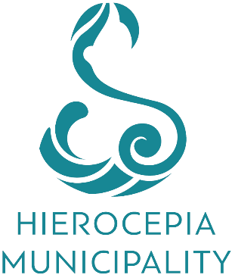

Documentation for a civil wedding in Hierocepia Municipality

ISRAELI CITIZENS

Regarding your civil marriage in Hierocepia Municipality, please note that you will be requested for the following documents:

1. Single status certificate from the Ministry of Interior in Israel (Blue Paper).

2. Valid Passport.

3. Change of Name (if applicable).

4. Divorce certificate (if applicable).

5. Death certificate (if applicable).

6. Adoption certificate (if applicable).

PLEASE NOTE:

All the above documents must be original documents officially translated into English and are valid ONLY for three (3) months. Documents must also be legalized in the country of origin by carrying an APOSTILLE stamp.

